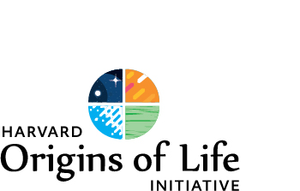

Undergraduate Research Prize Awards

Term Funding 2020-2021

The Harvard Origins of Life Initiative is again offering Academic Term Research Awards of up to $2,000 per undergraduate. The purpose of this prize award is to encourage talented undergraduates to conduct origins-related research under the mentorship of a faculty member or senior scientist in the Origins of Life Initiative.

A complete list of Origins member-mentors and links to their professional websites can be found at the following site: http://origins.harvard.edu/people/research-faculty

Application Process:

- Please review the mentors’ websites. If you determine that your research interests are compatible, please contact the faculty member or senior scientist directly, expressing your interest in working with him or her on an Origins-related research project as part of the Origins Academic Term Research Award program.

- If the mentor agrees, please ask him or her to email a brief statement of support to Kelly Colbourn, Associate Director at kelly.colbourn@cfa.harvard.edu.

- Please email Kelly a copy of your CV, as well as ½ -1 page a proposal, including the working title of your research project.

- There is no application deadline, awards are granted throughout the academic year.

Please note: term funding cannot be awarded for research related to academic year coursework or classes.

Should you have any further questions about these awards, please contact Kelly Colbourn at kelly.colbourn@cfa.harvard.edu.

